1. KM280107 in SAP has UOM 'M', meters. In MES the material has UOM ‘PCE’, pieces.

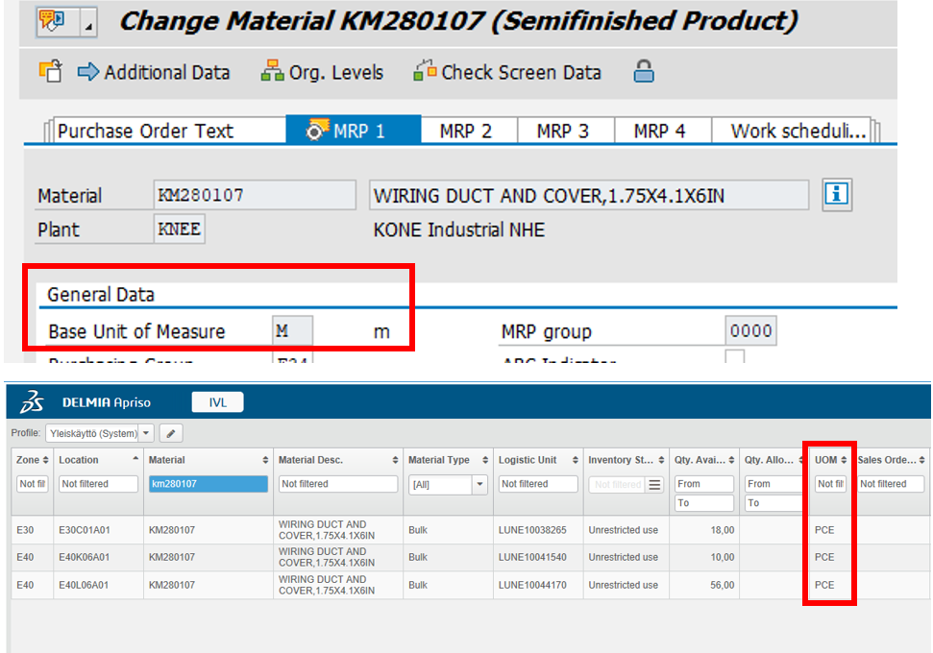

2. KM51098027 in SAP has UOM 'M', meters. In MES the same material has UOM 'FOT', foot.

